Welcome to the Franciscan LEAD Application System
Please read the following instructions then click the link at the bottom of the page to begin an application.
First round applications due April 1st, 2024

The application for Franciscan LEAD is a two-part online process. All youth applying for Franciscan LEAD will need an adult that knows them to serve as their reference. We prefer the referral person to be his/her youth minister, but in the event that the youth does not have a youth minister, it can be another adult that knows them well enough to answer questions about their faith life. The referral must be a non-family member over the age of 21. All applications and referrals must be submitted through the online process. If you have any questions, please email franciscanlead@franciscan.edu.

How to apply online for Franciscan LEAD:
- Before beginning the online application process, the youth applicant:
  - Must be planning to attend a Steubenville Youth Conference for the summer of 2024.
    - Note for 2024: Franciscan LEAD will only be offered the weeks prior to all Steubenville Main Campus Youth Conferences (Main Campus 1-4), Steubenville Northwest, Steubenville of the Rockies, and Steubenville St. Paul Youth Conferences.
  - Must have spoken with their youth minister/group leader and decided together that the youth is ready to apply to participate in Franciscan LEAD. If you are a youth who is interested in Franciscan LEAD, please contact your youth minister/group leader to discuss this opportunity before continuing with the application process.
  - Must have the following pieces of information:
    - A valid email address for themselves.
    - A recent digital photo of themselves to upload to the application.
    - The name and email address of the adult who will be serving as their reference.
    - The youth minister’s name, email address, and phone number (if the reference is someone other than youth minister).
    - The name of the Parish/Diocese/Group the youth is registered under for the youth conference weekend.
    - The name of the Group Leader that their Parish/Diocese/Group is registered under for the youth conference (if it is someone other than their youth minister).
- Once the requirements above have been met, the applicant should click the link below and follow the online application process. Once the application is started, the youth may save the application to complete it at a later time.
- When the youth applicant submits his/her completed application, the adult submitting the referral will receive an automatic email that will contain a link to the online referral form as well as a copy of the completed youth application. Please note: the youth must submit their application before the referral form can be completed.
- The final step will be the adult reference completing and submitting the online referral form. Once this is done, the application process is complete and the application and referral form will be reviewed. The youth application will not be reviewed until a completed referral is submitted.
- Notice of Acceptance: The first round of Franciscan LEAD acceptance emails will be sent no later than Friday, April 12th, 2024. To be considered in this first round of acceptance, both your application and referral form must be submitted by April 1, 2024. There is the possibility of being placed on a waitlist even if you submitted your application and referral form before April 1. When we receive more applications than spots available for this first round, there are several factors when considering applicants. If you are not accepted for Franciscan LEAD this year or if you are placed on the waitlist, you will receive a notification on April 12 as well. After April 1, applications will continue to be reviewed and accepted on a first-come first-serve basis. Please note that some locations will fill up sooner than others.
- Note for 2024 LEAD Weeks: In order to successfully host Franciscan LEAD, we must reach a certain number of participants by the April 1 deadline. If we do not reach this number, we may need to cancel Franciscan LEAD for that week due to financial hindrances.
Please feel free to email us at franciscanlead@franciscan.edu to learn whether there are spots available at the site for which you would like to apply. Or call us at 740-284-5876 with any questions you may have.

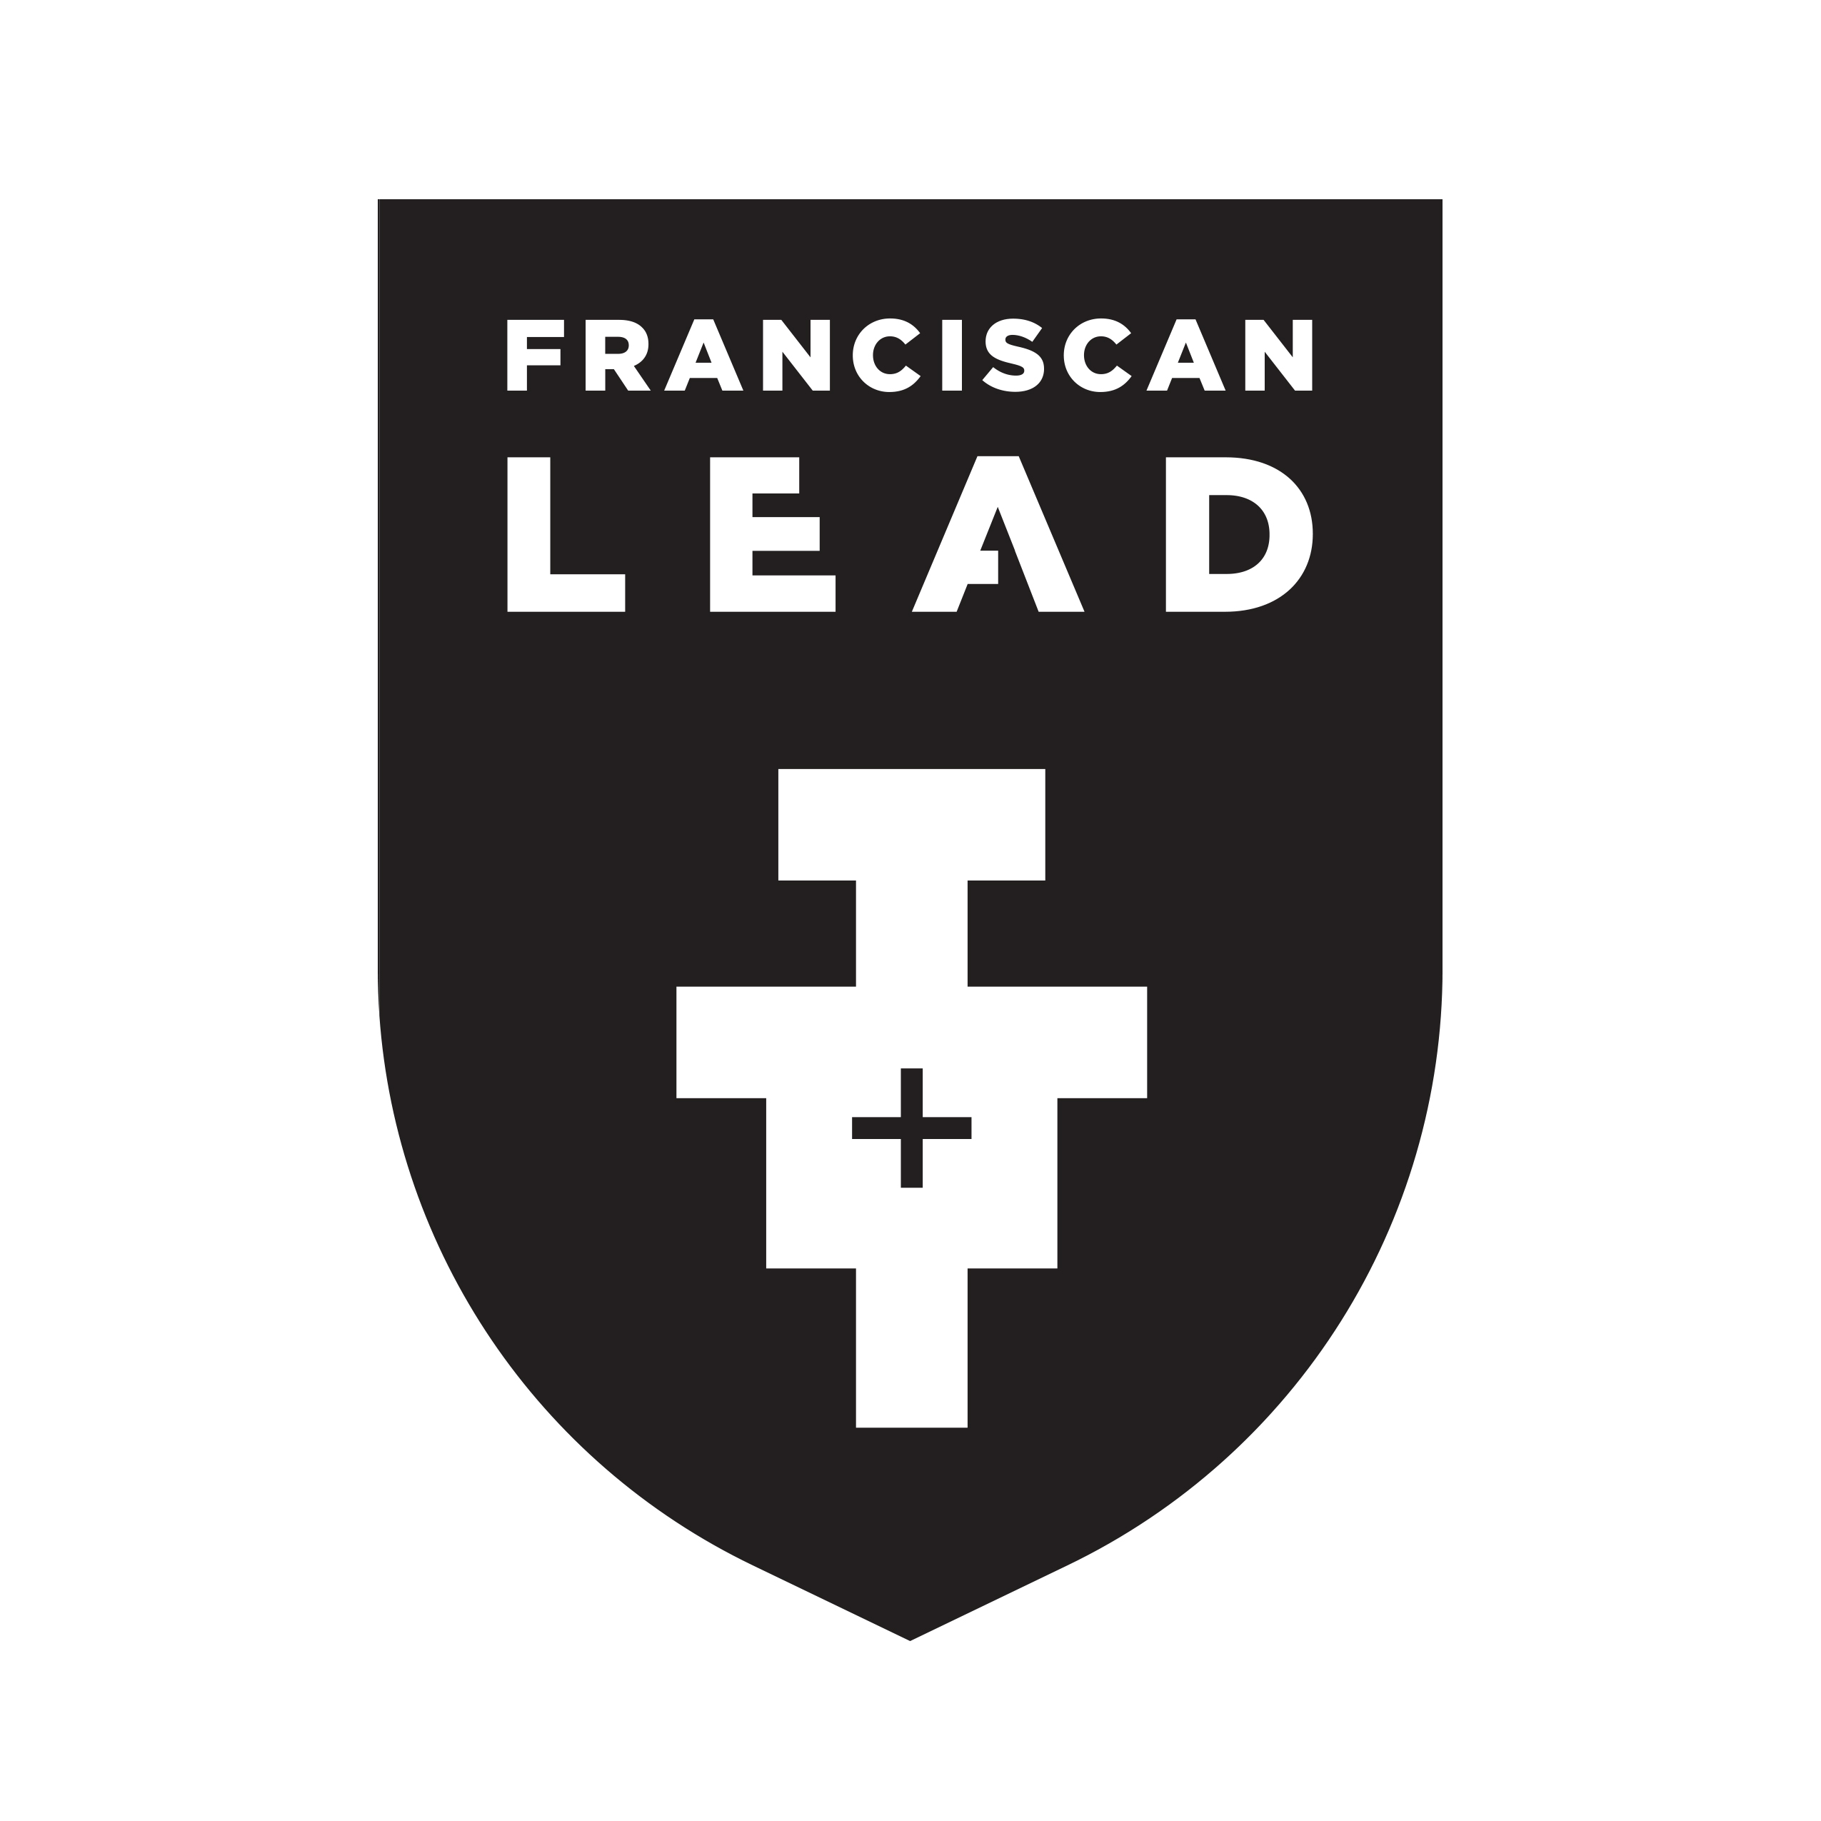
Click here to begin an application: Embedded link

